**UJIAN TENGAH SEMESTER GENAP**

**PRAKTIKUM ALGORITMA DAN STRUKTUR DATA**



**NAMA : DIMAS ADI BAYU SAMUDRA**

**KELAS : 1A**

**NO. ABSEN : 08**

**NIM : 2341720169**

**PROGRAM STUDI TEKNIK INFORMATIKA**

**JURUSAN TEKNOLOGI INFORMASI**

**POLITEKNIK NEGERI MALANG**

**TAHUN 2024**

**UJIAN TENGAH SEMESTER GENAP**

**PRAKTIKUM ALGORITMA DAN STRUKTUR DATA**

Code AlatPesta08

|  |
| --- |
| public class AlatPesta08 {  int kodeAlat08;  String namaAlat08;  double hargaSewa08;  int stock08;  public AlatPesta08(int kodeAlat08, String namaAlat08, double hargaSewa08, int stock08){  this.kodeAlat08 = kodeAlat08;  this.namaAlat08 = namaAlat08;  this.hargaSewa08 = hargaSewa08;  this.stock08 = stock08;  }  void tampil(){  }  void tampilDataAlatPesta(){  System.out.println("Kode alat = " + kodeAlat08);  System.out.println("Nama Alat = " + namaAlat08 );  System.out.println("Harga Sewa = " + hargaSewa08);  System.out.println("stock yang ada = " + stock08);  }  } |

Code MenuAlatPesta08

|  |
| --- |
| public class MenuAlatPesta08 {  AlatPesta08 listAlatPesta08 [] = new AlatPesta08[5];  int idx08;  void tambah08(AlatPesta08 m){  if (idx08 < listAlatPesta08.length) {  listAlatPesta08[idx08] = m;  idx08++;  } else{  System.out.println("Data Sudah Penuh ");  }  }  void tampil08(){  for (AlatPesta08 m08 : listAlatPesta08) {  if (m08 != null) {  m08.tampilDataAlatPesta();  }  }  }    void bubblesortHarga08(){  for (int i = 0; i < listAlatPesta08.length-1; i++) {  for (int j = 1; j < listAlatPesta08.length-i; j++) {  if (listAlatPesta08[j] != null && listAlatPesta08[j-1] != null && listAlatPesta08[j].hargaSewa08 < listAlatPesta08[j-1].hargaSewa08) {  AlatPesta08 tmp08 = listAlatPesta08[j];  listAlatPesta08[j] = listAlatPesta08[j-1];  listAlatPesta08[j-1] = tmp08;  }  }  }  }  void bubblesortKode08(){  for (int i = 0; i < listAlatPesta08.length-1; i++) {  for (int j = 1; j < listAlatPesta08.length-i; j++) {  if (listAlatPesta08[j] != null && listAlatPesta08[j-1] != null && listAlatPesta08[j].kodeAlat08 < listAlatPesta08[j-1].kodeAlat08) {  AlatPesta08 tmp08 = listAlatPesta08[j];  listAlatPesta08[j] = listAlatPesta08[j-1];  listAlatPesta08[j-1] = tmp08;  }  }  }  }    public int FindSeqSearch08(int cari){  int posisi = 0;  for (int j = 0; j < listAlatPesta08.length; j++) {  if (listAlatPesta08[j].kodeAlat08 == cari) {  j = posisi;  break;  }  }  return posisi;  }  public void tampilPosisi08(int x, int pos){  if (pos != 0) {  System.out.println("Data : " + x + " Ditemukan pada index : " + pos );  } else {  System.out.println("Data : " + x + " tidak Ditemukan" );  }  }  public void TampilData08(int x, int pos) {  if (pos != -1) {  System.out.println("Kode Alat\t: " + x );  System.out.println("Nama Alat\t\t: " + listAlatPesta08[pos].namaAlat08);  System.out.println("Harga Sewa\t: " + listAlatPesta08[pos].hargaSewa08 );  System.out.println("Stock\t\t: " + listAlatPesta08[pos].stock08);  } else {  System.out.println("data " + x + " tidak ditemukan");  }  }  } |

Code MainAlatPesta08

|  |
| --- |
| import java.util.Scanner;  public class mainAlatPesta08 {    public static void main(String[] args) {  Scanner sc = new Scanner(System.in);  Scanner sc1 = new Scanner(System.in);  MenuAlatPesta08 data08 = new MenuAlatPesta08();  int jumAlat08 = 3;  System.out.println("_____________________________________________");  System.out.println("Masukkan data08 Alat Pesta : ");  for (int i = 0; i < jumAlat08; i++) {  System.out.println("_____________________________________________");  System.out.print("Kode Alat \t: ");  int kodeAlat08 = sc.nextInt();  System.out.print("Nama Alat \t: ");  String namaAlat08 = sc1.nextLine();  System.out.print("Harga Sewa \t: ");  int hargaSewa08 = sc.nextInt();  System.out.print("stock \t\t: ");  int stock08= sc.nextInt();    AlatPesta08 m08= new AlatPesta08(kodeAlat08, namaAlat08, hargaSewa08, stock08);  data08.tambah08(m08);  }  System.out.println("_____________________________________________");  System.out.println("data keseluruhan Alat Pesta : ");  data08.tampil08();    System.out.println("______________________________________________");  System.out.println("Menu ");  System.out.println("1. Tampilkan data dengan dari harga terendah");  System.out.println("2. Tampilkan data dengan dari kode terendah");  System.out.println("3. Cari data ");  System.out.println("______________________________________________");  System.out.println("Masukan Pilihan Menu Anda");  int menu08 = sc.nextInt();  System.out.println("______________________________________________");  if (menu08 == 1) {  System.out.println("Sorting dari Harga Terendah");  data08.bubblesortHarga08();  data08.tampil08();  } else if (menu08 == 2) {  data08.bubblesortKode08();  data08.tampil08();  } else if (menu08 == 3) {  System.out.println("Pencarian data08 ");  System.out.println("Masukkan Kode Alat Pesta yang dicari: ");  System.out.print("Kode Alat Pesta : ");  int cari = sc.nextInt();  System.out.println("menggunakan sequential Search");  int posisi = data08.FindSeqSearch08(cari);  data08.tampilPosisi08(cari, posisi);  data08.TampilData08(cari, posisi);  } else {  System.out.println("Menu yang anda pilih tidak ada");  }        }  } |

Hasil Run

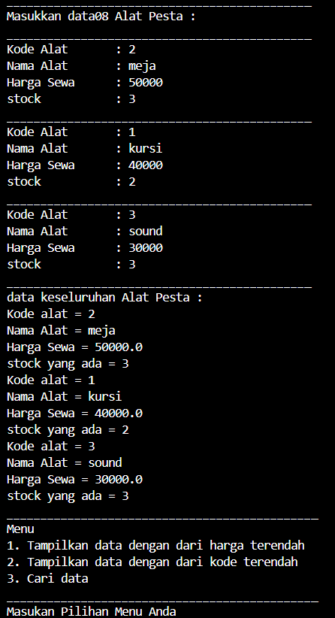

Menu 1 = sorting harga ascending menggunakan bubble sort

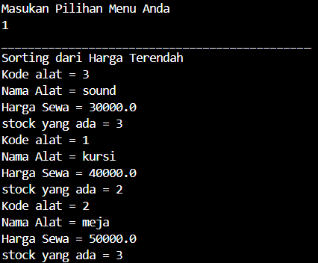

Menu 2 = sorting kode ascending menggunakan bubble sort

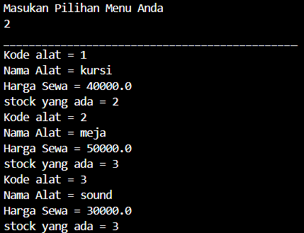

Menu 3 = searching menggunakan FindSeqSearch

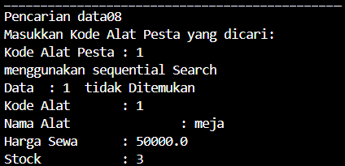

|  |
| --- |
| AlatPesta08 |
| - kodeAlat08 : int  - namaAlat08 : String  - hargaSewa08 : double  - stock08 : int |
| - AlatPesta08(int kodeAlat08, String namaAlat08, double hargaSewa08, int stock08) : public  - tampilDataAlatPesta() : void |